Edina Trust Bulb Project Extension
Guidance for Teachers and Project Leaders on this Year’s Results
A big thank you!
Well done to all schools that sent data for the Bulb Project this year! Your input has been invaluable in looking at our hypotheses. Even if you did not manage to get data to us this year, we hope that this project has been fun and useful for teaching various curriculum topics. We have a quick survey online where we would love to get your feedback:
https://www.surveymonkey.com/r/KRYN9RN
Amgueddfa Cymru – National Museum Wales (AC) will produce a paper on the results of the bulbs planted in pots for all schools. This will be distributed to the schools involved and can be accessed on the AC website: www.museumwales.ac.uk/spring-bulbs/
This year 100 schools took part in the Edina Trust’s extension Bulb Project, which involves comparing the flowering dates and heights between bulbs planted in pots and bulbs planted in the ground. A big thank you to the schools that returned their data!
 | Scotland | England | N Ireland | Wales* | UK
Participating Schools | 28 | 44 | 27 | 75 | 174
Schools that returned weather data | 24  (86%) | 30  (68%) | 23  (85%) | 54  (72%) | 131  (75%)
*Only one Welsh school took part in the Edina extension project this year, while 74 took part in the core Welsh project. For the weather data and flowering dates for bulbs in pots, the data from the core Welsh schools was included.

We have created a PowerPoint presentation that uses the weather data and flowering dates submitted by schools to compare differences across the UK as well as differences between this year and previous years of the project.

We have also created some fun quizzes that pupils can do by themselves, which don’t require them to use PowerPoint. You can find more information on page 10!

Total Rainfall per School between November 2024 – March 2025
recorded by schools

Country | Total rainfall (mm)
UK Average | 277
Scotland | 243
England | 278
N. Ireland | 238
Wales | 350

As is the case nearly every year, Wales had the most rain recorded! On average, the amount of rain recorded by each school is a lot lower than last year. These amounts are calculated by adding all of the rain recorded by each school together, and dividing it by the number of schools in each country, to get the mean result.
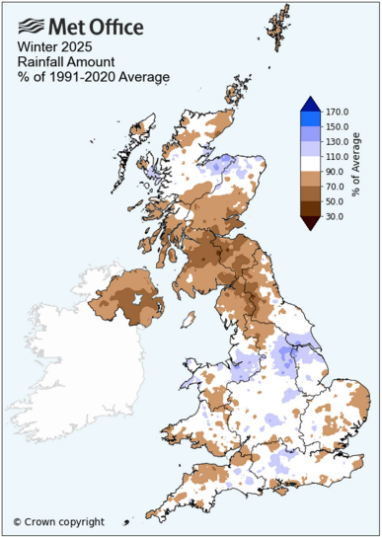
We can compare these figures to the Met Office data to get a better idea of rain patterns across the UK. The map here shows the amount of rain from Winter 2025. We can see that a lot of the map is brown (lower than average rainfall). You can find out more information and look at weather summaries for the other months on the Met Office website.
Water is of course vital for plants, but more rain does not always mean that daffodils will thrive. Daffodils will not grow underwater! Being too moist also benefits moulds that are detrimental to the daffodil bulbs. We would ask pupils to think about whether they expect bulbs to flower earlier if they get a lot of rain, or whether they would flower later?

Average Temperature During the Bulb Project
recorded by schools

Country | Average Temperature (°C)
UK 2023/24 | 7.1
Scotland | 6.0
England | 7.0
N. Ireland | 8.0
Wales | 7.5
This bar chart shows the average temperature in each country when combining all the results between November and March. As expected, Scotland was the coldest again this year – but that isn’t always the case! Northern Ireland was the warmest country this year, meaning it was both the warmest and the driest country. There isn’t a huge difference in the average temperature though – only 2°C.
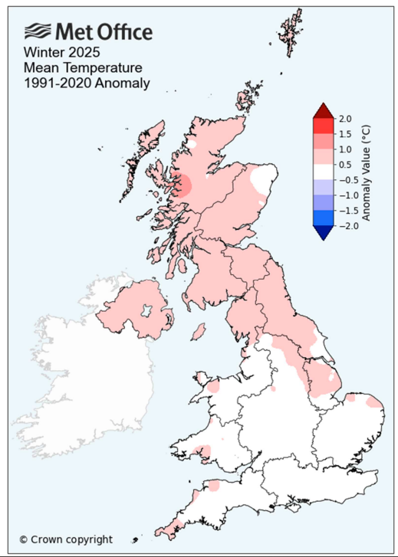
Bulbs are sensitive to temperature changes and begin to grow as the soil warms up in spring. This means that a mild winter can cause daffodils to flower earlier, or a cold spring can cause them to flower later.

As with rainfall, it is not always good to be too warm. As well as potential drought, too much warmth can be beneficial to pests such as the Large Narcissus Fly. The fly’s larvae live inside and eat daffodil bulbs. Due to the warmer climate this fly, which was once only found in the South-West, has been able to spread across the UK.

The Met Office report shows that the UK was generally warmer than average during Winter 2025. There were a few cold periods such as the days following Storm Darragh (6-8th December) and in January.
Temperature each month between November 2024 – March 2025
recorded by schools

This graph shows the temperature each month from November 2024 – March 2025. We can see that the temperature dropped until January, and then it has risen in February and March – the same pattern as last year.
Below are the average temperatures each month in each of the four countries:
ºC | November | December | January | February | March
Scotland | 7.1 | 3.3 | 3.2 | 7.4 | 9.5
England | 6.1 | 5.8 | 4.4 | 6.4 | 11.1
N. Ireland | 9.6 | 6.4 | 5.8 | 7.9 | 10.4
Wales | 8.0 | 6.5 | 6.7 | 5.4 | 10.6

Our hypotheses
Next, we look back at our hypotheses – our predictions about daffodils’ flowering and height:
- Schools that record higher temperatures during the Bulb Project will have the earliest flowering daffodils. The effect of temperature will be more pronounced with the daffodils in pots compared to those in the ground.
- Schools that record more daily rainfall during the Bulb Project will have the earliest flowering daffodils.
- On average, daffodils in pots will flower before those planted in the ground.

 | Pots | Ground | Average
Scotland | 3rd March | 11th March | 7th March
England | 7th March | 12th March | 9th March
N. Ireland | 6th March | 7th March | 6th March
Wales | 8th March | 5th March | 8th March
The results this year were very close, with a straight run of average flowering dates between 6th – 9th March! It’s hard to say that there was any significant difference this year.
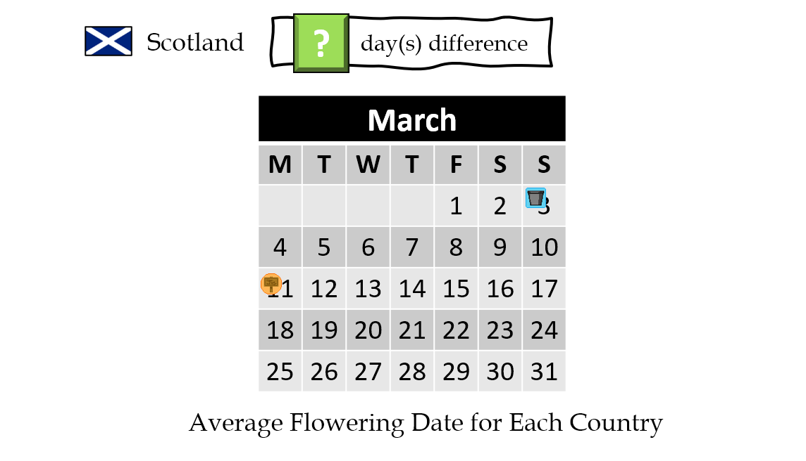
This slide looks at the difference in dates between bulbs flowering in pots and those in the ground. Scotland had the longest gap with 8 days between bulbs in the ground flowering and bulbs in pots flowering. England had 5 days difference, and the other countries were closer with Wales having 3 days difference and N. Ireland only one.
We can’t be sure why this is. A lot of factors can influence the timing of bulbs flowering. For example, some schools may keep their bulbs in pots near to a heated building, some may keep them in a more sheltered and shaded area, while others are planted in open sunlight. Perhaps these have more of an effect than the temperature, so the conclusion can’t be drawn as to whether the bulbs in pots are more affected by temperature. This is just a part of science!
Thank you to all the schools that reported their flowering dates or let us know that their flowers didn’t open. The more data we have, the more accurate our results ought to be. A big thank you to everyone who logged into the website to record their flowering dates/did not flower result!

The slide shows the difference in flowering dates between bulbs in pots and in the ground, and between Spring 2024 and Spring 2025. These are the average flowering dates across the whole UK.
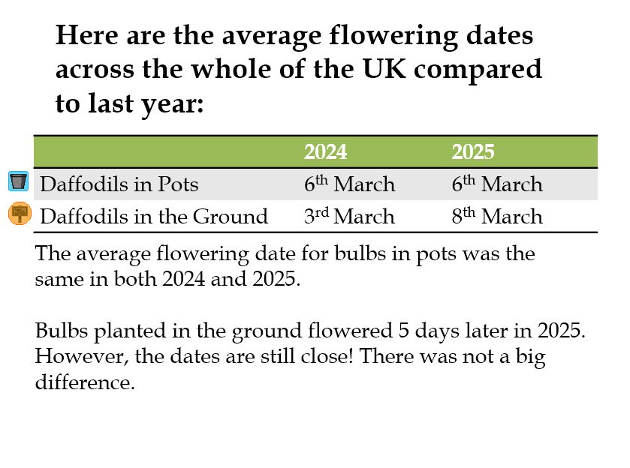

Now we will look at the temperature and rainfall across multiple years of the Bulb Project to see if there are any differences.
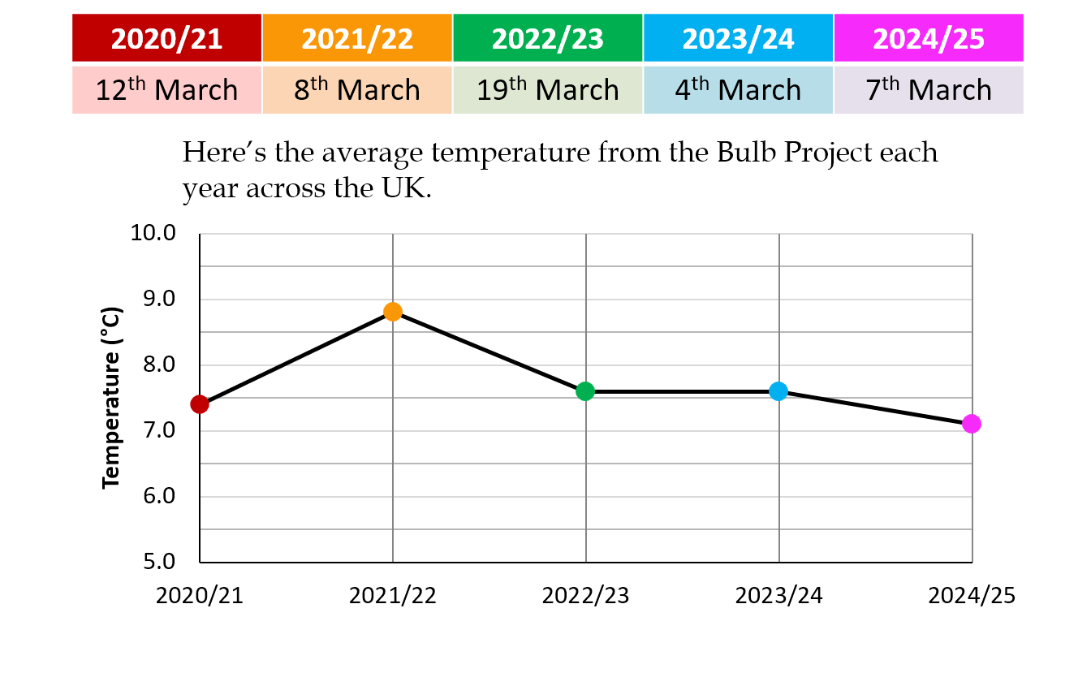 This slide shows the average flowering date from the last five years of the project. The chart below shows the average temperature from each year. I have colour coded each point on the chart to make it easier to match to the year. Can you spot any pattern here? There is not a particularly clear trend.
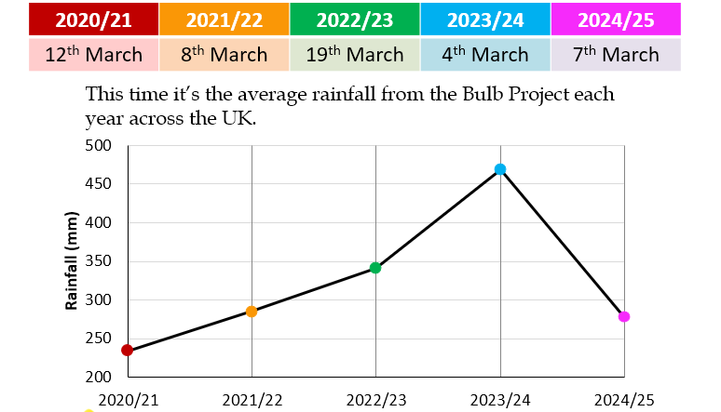
The next slide looks at the rainfall. There wasn’t as much rain this year compared to previous years of the project. There was a similar amount of rain in 2021/22 and 2024/25, and the flowering dates are very close. There was a lot of rain in 2023/24, when the flowering date was earliest. However, this pattern doesn’t always hold true.
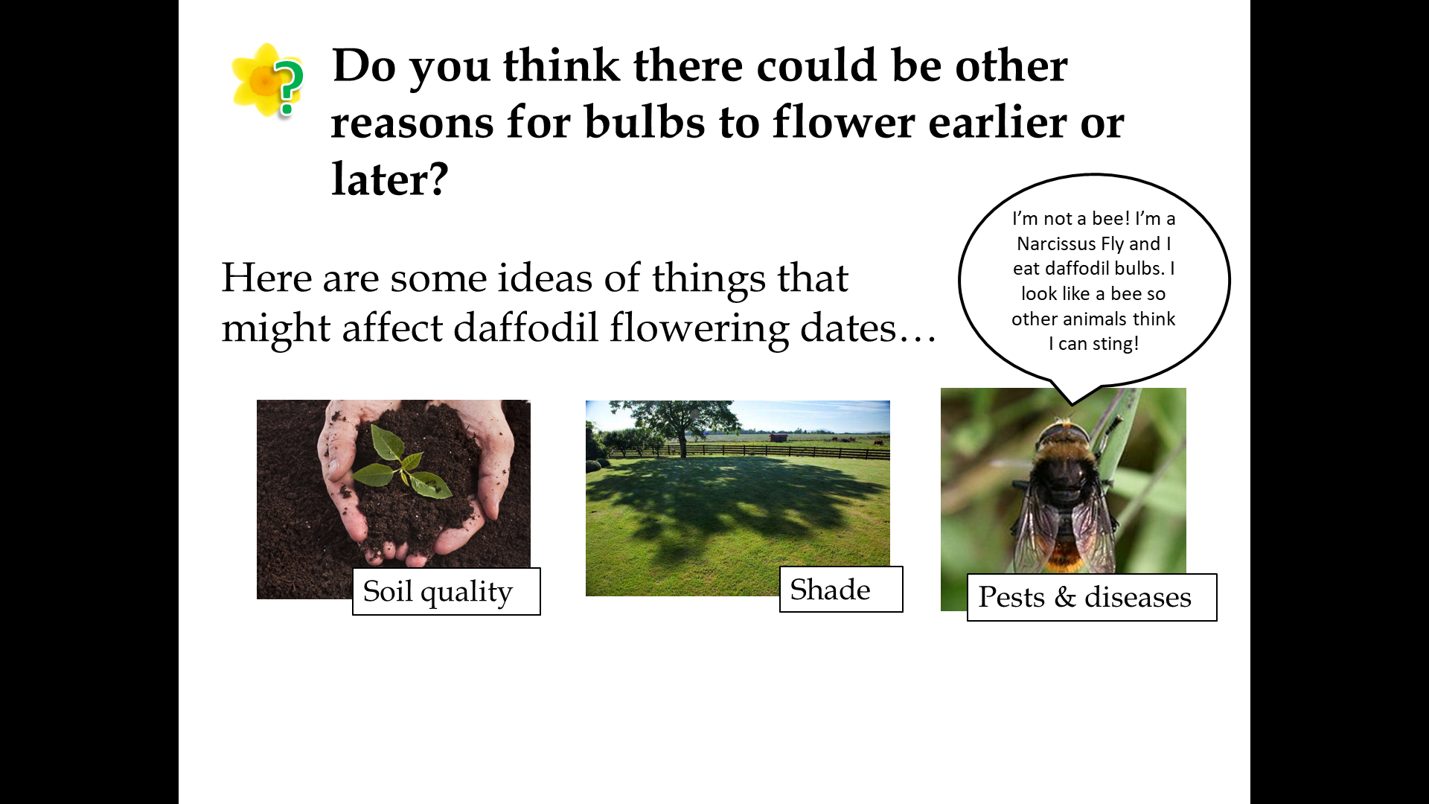
The next slide shows some of our ideas for other factors that might be affecting the growth of the daffodils. They might explain why the results don’t always match our predictions. We ask pupils here to consider how they might change the Bulb Project to account for these factors. Some are easier to control than others! For example, perhaps we could ask all schools to use exactly the same type of compost, or to make sure the bulbs are planted in areas with full sun away from the school building, which can also warm the surrounding area slightly due to the buildings being heated. These are not practical to implement due to the nature of the project, but they would make the investigation more of a fair test.

- Soil Quality
We cannot be sure how much of an effect the type of soil or compost has on the growth of daffodils. Compost will hold moisture more effectively than soil, and different types of compost will hold moisture more effectively – we recommend peat-free compost due to environmental concerns. Using compost over soil should also reduce weed growth since it should not contain any stray seeds. Good drainage is important as waterlogged soil can cause the bulbs to rot, and the pH and amount of nutrients (e.g. nitrogen and potassium), in the soil will also affect growth. We would have to find a way for all schools to use the same compost to eliminate this from our investigation. Differences in soil quality might affect bulbs planted in the ground more than those in pots due to the many different soil types that can be found in different areas of the UK.

- Sunlight/Shade
Plants need sunlight in order to grow. Bulbs that are grown in shaded areas might grow taller in search of light, or they may not get enough sunlight to warm up and might flower later. We ask schools to keep their pots near the bulbs planted in the ground, if possible, to reduce the impact of this. There is not much else we can do as the amount of shade and hours of sunlight will differ between all schools.

- Pests and Diseases
We don’t have much control over this. We advise schools to keep their bulbs in a cool, dry place before planting day. Let us know if you notice your flowers are affected by pests!

Finally we will look at the average height of daffodils in each country.

This year there wasn’t much difference at all in the height of daffodils. Scotland had the tallest daffodils, but only just! From this year’s data alone, we couldn’t say there is any correlation between the height of daffodils and the amount of rain or the temperature.

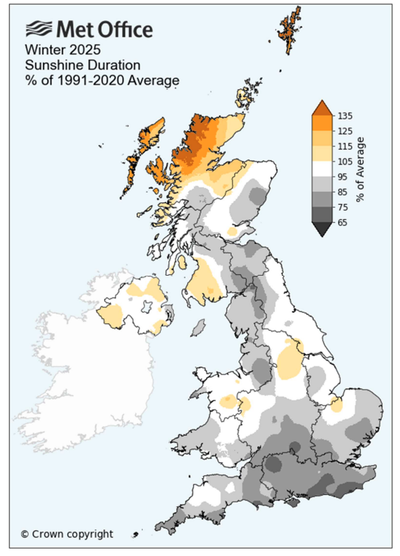
One other factor we could consider is the amount of sunlight the daffodils get. The Met Office has the map pictured here, which shows the sunshine duration compared to average. Grey areas have less sun than average, and orange areas have more sunshine. Since plants also need sunlight in order to survive and grow, this could have an effect. This can be hard to compare between schools, e.g. some schools might keep their bulbs in a shaded area, while others are out in the open.

Mystery Bulbs
Spoilers: the mystery bulbs this year were a mix – you may have received either irises or grape hyacinths! Were you able to see the mystery bulbs flowering yet this year? They may open as late as May. We would like to encourage pupils to have a look for other spring bulbs flowering near where they live as well!

Follow Up Activities

- Kahoot Quizzes
We have created some fun quizzes that pupils can complete using the website Kahoot! There are two different quizzes relating to temperature and rainfall results sent in by pupils all around the UK. Level One is intended for a lower ability level/younger pupils, while Level Two is more in depth for higher ability/older pupils. The links to these quizzes can be found at www.edinatrust.org.uk/bp-results

We would love to hear your feedback!

- Bulb Project Board Game
A professionally printed copy of this game was sent to all schools last October. However, if you direct pupils to our website linked below, they will find a board game that can be downloaded and printed. This game is designed to encourage discussion about the various factors that could have affected the growth of your daffodils and crocuses.

Please go to this web page to download the board game and instructions:
https://www.edinatrust.org.uk/bp-results

- Investigate more results by looking at the Met Office Climate Maps and Data
You can look at climate summaries for each season and each month going back to 2018 among many other things. What patterns can you see? How do the results recorded by the Met Office compare to the Bulb Project results?
https://www.metoffice.gov.uk/research/climate/maps-and-data

https://thedaffodilsociety.com/wordpress/a-guide-to-dafodils/pests-diseases/

