


TAPS Scotland

Focused assessment of scientific skills
Topic:  Materials | Primary 3  Age 6-7 |  | Activity title:  Drops on a coin
Scientific skills focus    Carries out: Observes and collects information using appropriate equipment. |  | Curriculum link  I can make and test predictions about solids dissolving in water and can relate my findings to the world around me. SCN 1-16a
Assessment focus
- Can children observe the liquid droplets carefully?
- Can children collect information about the number of droplets?
Activity Today we are chemists testing the properties of liquids
Provide pairs with a coin, water and a dropper/pipette. Ask them to explore how many drops they can get onto the coin before the water spills over (surface tension breaks).
(Adjust the following as appropriate for your class eg exploring different liquids or dissolving).
Do you think dissolving something in the liquid would change its properties?
Could link to pond skaters using surface tension – can pond skaters skate on salty water?
Discuss what could be dissolved in the water and what other liquids the pupils could try e.g. salt water, sugar water, squash, coffee etc. Or link to salty lakes and try different amounts of salt – what effect does salty water have on surface tension/pond skaters?
Ask the pupils to select (or make if appropriate) ~3 liquids to try, repeating if possible.
Ask them to record their results, so that they can be discussed later. Pupils could record in different ways, e.g. by making a tally or recording the total.
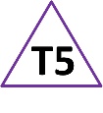
Share pupil recordings and discuss both the findings and the way children have chosen to record them. (Most likely to be a wide range of results, so difficult to draw conclusions, but good for discussion about observations e.g. hard to keep drop size constant).

Adapting the teaching
Support: Compare 2 liquids.
Extension: Repeat the tests and explore why the results are different each time.
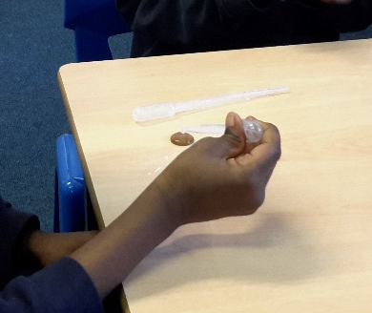
Other ideas: Try different sized coins.

Questions to support discussion
- What happens when you add more drops?
- How do you know when to stop counting?
- How are you recording what happens?
- Can you tell me what you found out here?
- How many times have you tried liquid x?

Benchmark indicators
Working towards: Pupils count drops but may not immediately notice when the surface tension breaks. Pupil recording of results is unclear, or only completed from memory after the task.

Achieved: Pupils observe the liquid carefully to decide on the number of drops. Pupils record their results in a way that others can understand.

Possible ways to go further: Pupils notice factors which could affect the results e.g. variability in the size of droplets. Pupil recordings is clear regarding any repeated measures.
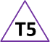 Teacher box 5 - adapt teaching. See TAPS pyramid for more examples.

