Edina Trust Bulb Project Extension
Guidance for Teachers and Project Leaders on this Year’s Results
A big thank you!
Well done to all schools that sent data for the Bulb Project this year! Your input has been invaluable in looking at our hypotheses. Even if you did not manage to get data to us this year, we hope that this project has been fun and useful for teaching various curriculum topics. We have a quick survey online where we would love to get your feedback:
https://www.surveymonkey.co.uk/r/2CLP5QXb
Amgueddfa Cymru – Museum Wales (AC) will produce a paper on the results of the bulbs planted in pots for all schools. This will be distributed to the schools involved and can be accessed on the AC website: www.museumwales.ac.uk/spring-bulbs/
This year 100 schools took part in the Edina Trust’s extension Bulb Project, which involves comparing the flowering dates and heights between bulbs planted in pots and bulbs planted in the ground. A big thank you to the schools that returned their data!
 | Scotland | England | N Ireland | Wales* | UK
Participating Schools | 31 | 39 | 26 | 4 | 100
Schools that returned weather data | 18  (58%) | 16  (41%) | 17  (65%) | 2  (50%) | 53  (53%)
*Only four Welsh schools took part in the Edina extension project this year. For the weather data and flowering dates for bulbs in pots, the average date from all schools on the core Welsh project was used, which included an additional 30 schools.

We have created a PowerPoint presentation that uses the weather data and flowering dates submitted by schools to compare differences across the UK as well as differences between this year and previous years of the project.

We have also created some fun quizzes that pupils can do by themselves, which don’t require them to use PowerPoint. You can find more information on page 8!

Total Rainfall between November 2022 – March 2023
recorded by schools

Country | Average rainfall (mm)
UK Average | 341
Scotland | 310
England | 295
N. Ireland | 288
Wales | 470
Scotland, England, and Northern Ireland all had quite similar amounts of rain reported, while Welsh schools reported over 150mm more rain for the same period. Northern Ireland had the least rain but only just a little less than England. This trend can be seen almost every month apart from in February, when Wales actually had the least rain!
We can compare these figures to the Met Office data to get a better idea of rain patterns across the UK.
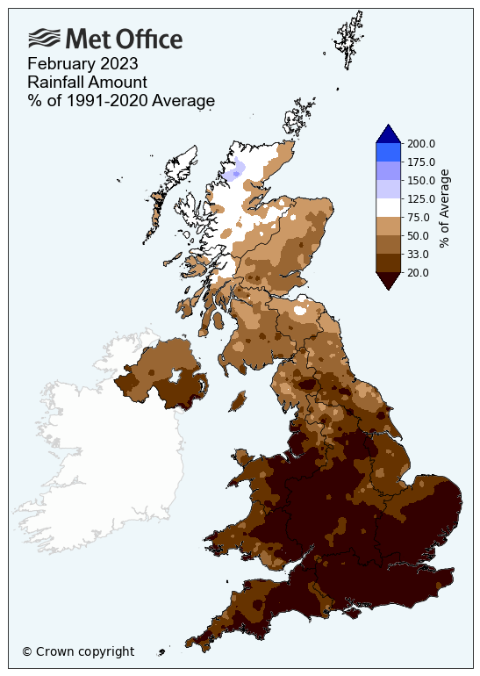
February was an interesting month as it was especially dry this year. For England, it was the driest February in 30 years. In the Met Office map to the left, the brown areas saw less rain than on average, while blue areas saw more rain than average. You can see that there are very few blue areas on this map and a lot of brown!
You can find out more information and look at weather summaries for the other months on the Met Office website.
Water is of course vital for plants, but more rain does not always mean that daffodils will thrive. Daffodils will not grow underwater! Being too moist also benefits moulds that are detrimental to the daffodil bulbs. We would ask pupils to think about whether they expect bulbs to flower earlier if they get a lot of rain, or whether they would flower later?
Average Temperature During the Bulb Project
recorded by schools

Country | Average Temperature (°C)
UK 2019 | 7.5
Scotland | 6.6
England | 7.7
N. Ireland | 7.5
Wales | 8.2
This bar chart shows the average temperature when combining all the results between November and March to compare the differences between the countries. As expected, Scotland was the coldest again this year – but that isn’t always the case! Wales was the warmest country this year, meaning it was both the warmest and the wettest. Since spring bulbs require water and sunlight to grow, do you expect that they would flower first in Wales? Read on to find out!

Bulbs are sensitive to temperature changes and begin to grow as the soil warms up in spring. This means that a mild winter can cause daffodils to flower earlier, or a cold spring can cause them to flower later.

As with rainfall, it is not always good to be too warm. As well as potential drought, too much warmth can be beneficial to pests such as the Large Narcissus Fly. The fly’s larvae live inside and eat daffodil bulbs. Due to the warmer climate this fly, which was once only found in the South-West, has been able to spread across the UK.

The Met Office report describes how unsettled the weather was this past winter. Overall it was milder and drier than average, however there were periods that were very cold with temperature reaching as low as -17.3°C in Aberdeenshire (13th December). We’ll look at another chart to get more information.

Temperature each month between November 2022 – March 2023
recorded by schools

This graph shows the temperature each month from November 2022 – March 2023. We can see that the temperature plummeted in December and has slowly increased until March. Scotland was the coldest every month. Wales was warmest in November, January, and March. England was warmest in February. Northern Ireland was warmest in December.
Below are the average temperatures each month in each of the four countries:
ºC | November | December | January | February | March
Scotland | 9.9 | 2.9 | 5.7 | 7.2 | 7.2
England | 11.2 | 4.1 | 6.4 | 8.2 | 8.5
N. Ireland | 10.7 | 5.1 | 6.1 | 7.7 | 8.1
Wales | 12.6 | 4.5 | 6.9 | 10.4 | 9.3

Our hypotheses
Next, we look back at our hypotheses – our predictions about daffodils’ flowering and height:
- Schools that record higher temperatures during the Bulb Project will have the earliest flowering daffodils. The effect of temperature will be more pronounced with the daffodils in pots compared to those in the ground.
- Schools that record more daily rainfall during the Bulb Project will have the earliest flowering daffodils.
- On average, daffodils in pots will flower before those planted in the ground.

 | Pots | Ground
Scotland | 10th March | 10th March
England | 18th March | 26th March
N. Ireland | 26th March | 18th March
Wales | 25th March | 23rd March
The results this year were a big surprise as schools in Scotland reported their daffodils flowering first, and schools in Wales reported them flowering latest. This is the opposite of what we would have expected from the weather data! What could have happened?
An extra slide was added this year looking at the number of daffodils that were reported as ‘did not flower’ as well as the number of flowering records returned.
We believe that a lot of flowers opened after the end of March when the Bulb Project ended and schools were on holiday. This is supported by the number of schools reporting that their flowers did not open. There were also a number of schools who sent us comments on how their daffodils didn’t grow at all or did not grow flowers (sometimes known as ‘blind daffodils’).
This may be due to us encouraging schools to let us know if their daffodils didn’t flower this year, as we anticipated a lot wouldn’t flower before the end of March.
We always appreciate when schools report their flowering dates or let us know that their flowers didn’t open. The more data we have, the more accurate our results ought to be. A big thank you to everyone who logged into the website to record their flowering dates/did not flower result!
Our hypothesis was that daffodils in pots would flower first. The data did not support our hypothesis this year since daffodils in pots opened first only in England.
We need to consider the other factors that could influence which bulbs grow and flower when we think about why our hypothesis was not correct.

The slide shows the difference in flowering dates between bulbs in pots and in the ground, and between Spring 2021 and Spring 2022. These are the average flowering dates across the whole UK.
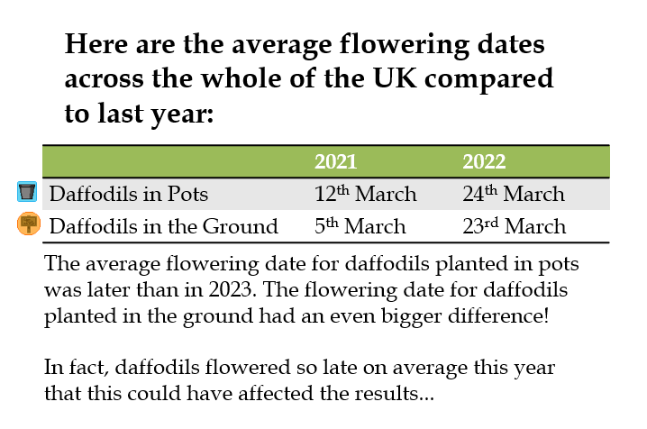
This is a graph showing the temperatures sent in by schools during the last five years of the Bulb Project. Daffodils flowered very late this year compared to last year, but this year was colder on average and quite mild overall. Schools reported colder temperatures in 2018-19 and 2020-21. Perhaps daffodils did not grow so well due to the intermittent cold snaps that the Met Office report talked about. Or perhaps some other factor came into it. Let’s think about the different factors that could have affected the results.

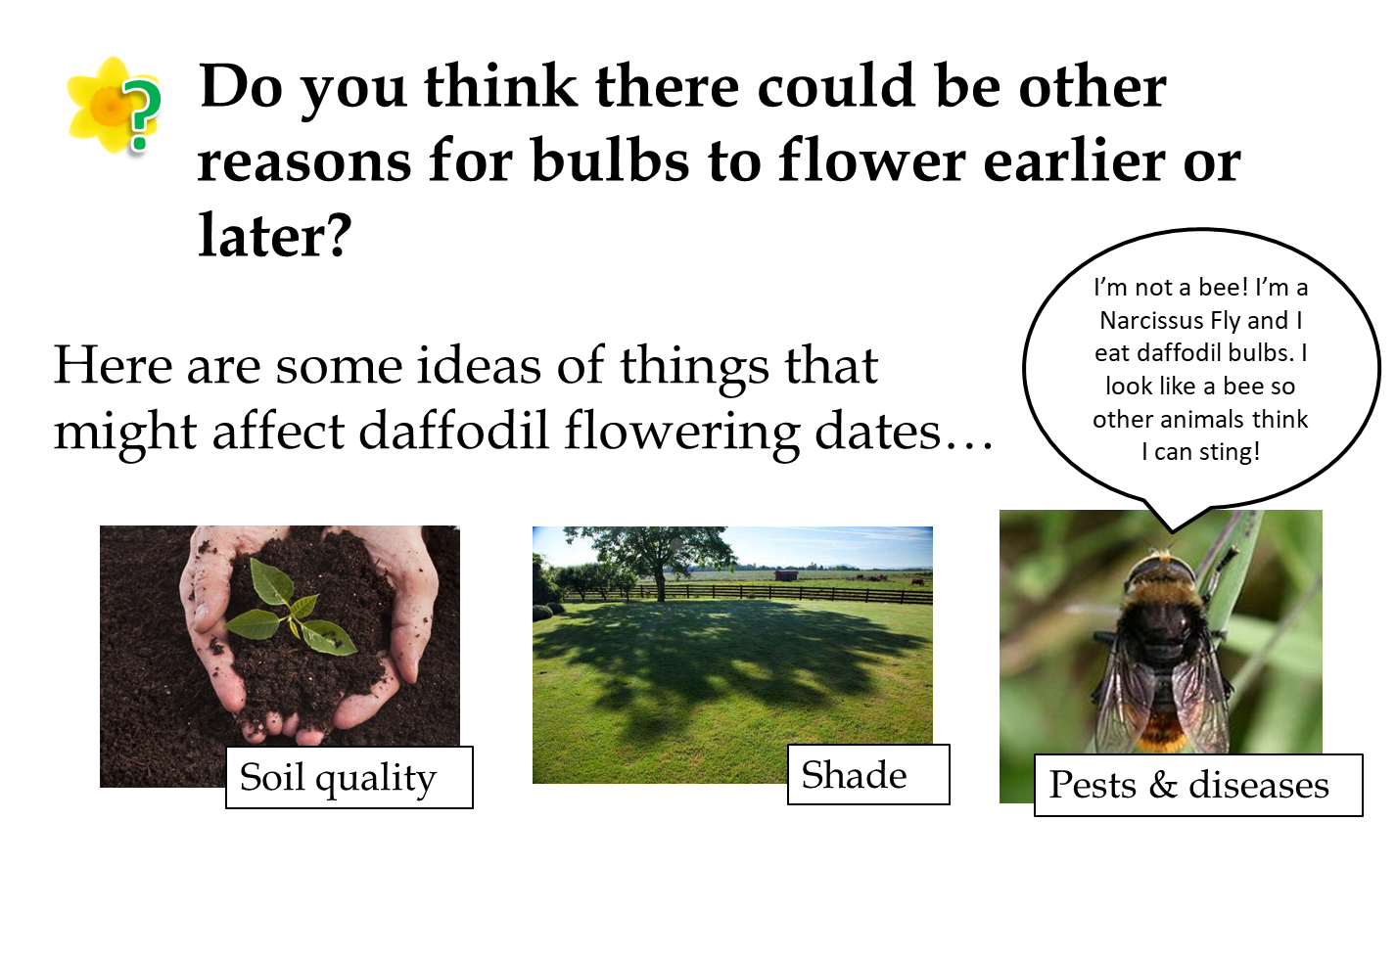

The slide shows some of our ideas for other factors that might be affecting the growth of the daffodils. They might explain why the results don’t always match our predictions.

- Soil Quality
We cannot be sure how much of an effect the type of soil or compost has on the growth of daffodils. Compost will hold moisture more effectively than soil, and different types of compost will hold moisture more effectively – we recommend peat-free compost due to environmental concerns. Using compost over soil should also reduce weed growth since it should not contain any stray seeds. Good drainage is important as waterlogged soil can cause the bulbs to rot, and the pH and amount of nutrients (e.g. nitrogen and potassium), in the soil will also affect growth. We would have to find a way for all schools to use the same compost to eliminate this from our investigation. Differences in soil quality might affect bulbs planted in the ground more than those in pots due to the many different soil types that can be found in different areas of the UK.

- Sunlight/Shade
Plants need sunlight in order to grow. Bulbs that are grown in shaded areas might grow taller in search of light, or they may not get enough sunlight to warm up and might flower later. We ask schools to keep their pots near the bulbs planted in the ground, if possible, to reduce the impact of this. There is not much else we can do as the amount of shade and hours of sunlight will differ between all schools.

- Pests and Diseases
We don’t have much control over this. We advise schools to keep their bulbs in a cool, dry place before planting day. Let us know if you notice your flowers are affected by pests!

Mystery Bulbs
Spoilers: the mystery bulbs this year were grape hyacinths! Were you able to see the mystery bulbs flowering yet this year? They may open as late as May. We would like to encourage pupils to have a look for hyacinths flowering near where they live as well!

Follow Up Activities

- Kahoot Quizzes
We have created some fun quizzes that pupils can complete using the website Kahoot! There are three different quizzes, relating to temperature and rainfall results sent in by pupils all around the UK. The separate rainfall and temperature versions are intended to be for higher ability levels, while the combined one for a lower ability level. The links to these quizzes can be found at www.edinatrust.org.uk/bp-results

We would love to hear your feedback!

- Bulb Project Board Game
A professionally printed copy of this game was sent to all schools last October. However, if you direct pupils to our website linked below, they will find a board game that can be downloaded and printed. This game is designed to encourage discussion about the various factors that could have affected the growth of your daffodils and crocuses.

Please go to this web page to download the board game and instructions:
https://www.edinatrust.org.uk/bp-results

- Investigate more results by looking at the Met Office Climate Maps and Data
You can look at climate summaries for each season and each month going back to 2018 among many other things. What patterns can you see? How do the results recorded by the Met Office compare to the Bulb Project results?
https://www.metoffice.gov.uk/research/climate/maps-and-data

https://thedaffodilsociety.com/wordpress/a-guide-to-dafodils/pests-diseases/

