Edina Trust Bulb Project Extension
Report for Teachers and Project Leaders
A big thank you!
Well done to all schools that sent data for the Bulb Project this year! Your input has been invaluable in looking at our hypotheses. Even if you did not manage to get data to us this year we hope that this project has been fun and useful for teaching various curriculum topics. We have a quick survey online where we would love to get your feedback:
https://www.surveymonkey.co.uk/r/XHJVMKD
The National Museum of Wales (NMW) will produce a paper on the results of the bulbs planted in pots for all schools. This will be distributed to the schools involved and can be accessed on the NMW website: www.museumwales.ac.uk/spring-bulbs/
This year 100 schools took part in the Edina Trust’s extension Bulb Project, which involves comparing the flowering dates and heights between bulbs planted in pots and bulbs planted in the ground. A big thank you to the schools that returned their flowering data!
Table 1: Data sets for the Edina Trust Bulb Project Evaluation
 | Schools in Extension Project | Schools in Scotland | Schools in England | Schools in Nor. Ireland | Schools in  Wales
All Schools | 100 | 28 | 45 | 20 | 7
Schools that provided flowering data | 46 (46%) | 13 (46%) | 21 (47%) | 7 (35%) | 5 (71%)

The 46 schools provided flowering dates and heights for 649 daffodils, as well as recording a total of 46 bulbs that did not flower before the end of the project. In the following analysis, local authorities have been divided into the four countries:
- Scotland: Dumfries & Galloway, Dundee, East Ayrshire, Fife, Inverclyde, North Ayrshire, North Lanarkshire, Renfrewshire, South Lanarkshire, West Dunbartonshire
- England: Lancashire, Lincolnshire, North East Lincolnshire, Oxfordshire, Sunderland, Wolverhampton
- Northern Ireland: Belfast, Derry/Londonderry, Strabane
- Wales: Conwy, Rhondda Cynon Taf

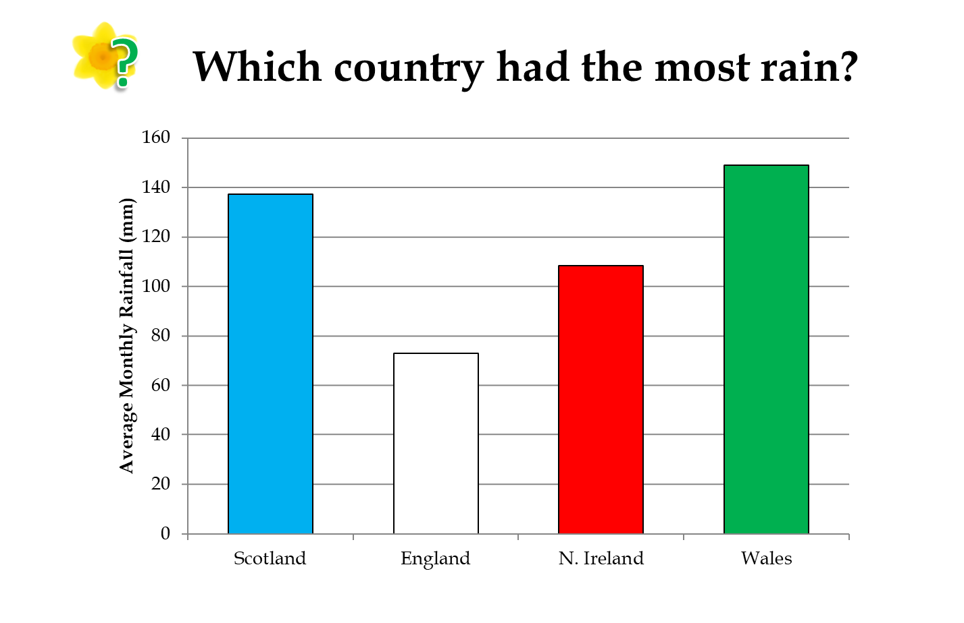

Country | Average rainfall (mm)
UK 2019 | 102.3
Scotland | 137.3
England | 72.9
N. Ireland | 108.3
Wales | 149
Wales had the most rain this year. To the right are the actual figures for each country plus the combined average for the UK, as recorded by the schools taking part in the Bulb Project.

Wales and Scotland being the rainiest areas is not surprising – see the map below from the Met Office. The west of Scotland, North-West England, and Wales have the most rainfall on average in Spring.
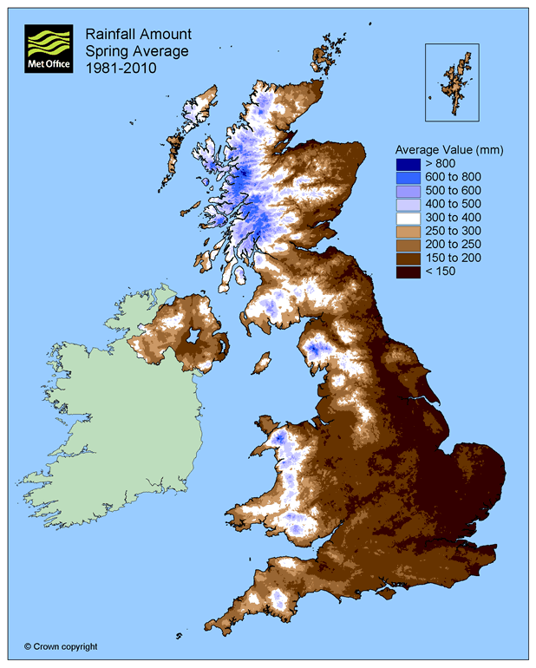
https://www.metoffice.gov.uk/public/weather/climate
Water is of course vital for plants, but more rain does not always mean that daffodils will thrive where there is the most rain. Daffodils will not grow underwater! Being too moist also benefits molds that are diseases to the daffodil bulbs.

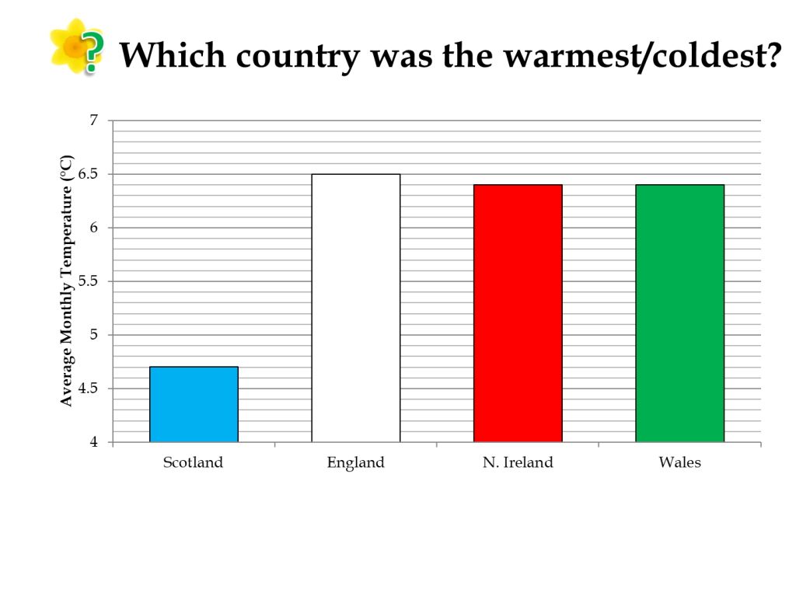

Country | Average Temperature (°C)
UK 2019 | 6.0
Scotland | 4.7
England | 6.5
N. Ireland | 6.4
Wales | 6.4
England was the warmest country this year on average, but Northern Ireland and Wales were so close that there was no significant difference. Scotland was by far the coldest area, which will come as no surprise to anyone, particularly those in Scotland! This is due to its higher latitude. Another factor, although it probably wouldn’t affect children taking their weather recordings during the day, is that Scotland being further north has fewer daylight hours during the winter. South Wales and South England can also benefit from warm, tropical winds coming from the south, whereas Scotland gets cold Arctic winds coming from the north.

The table to the right shows the actual values for the average temperature in each country and across the UK.

Bulbs are sensitive to temperature changes and begin to grow as the soil warms up in spring. This means that a mild winter can cause daffodils to flower earlier, or a cold spring can cause them to flower later. There was a big difference between spring 2018 and spring 2019 which we will come back to later.

As with rainfall, it is not always good to be too warm. As well as potential drought, too much warmth can be beneficial to pests such as the Large Narcissus Fly. The fly’s larva live inside and eat daffodil bulbs. Due to the warmer climate this fly, which was once only found in the South-West, has been able to spread across the UK.

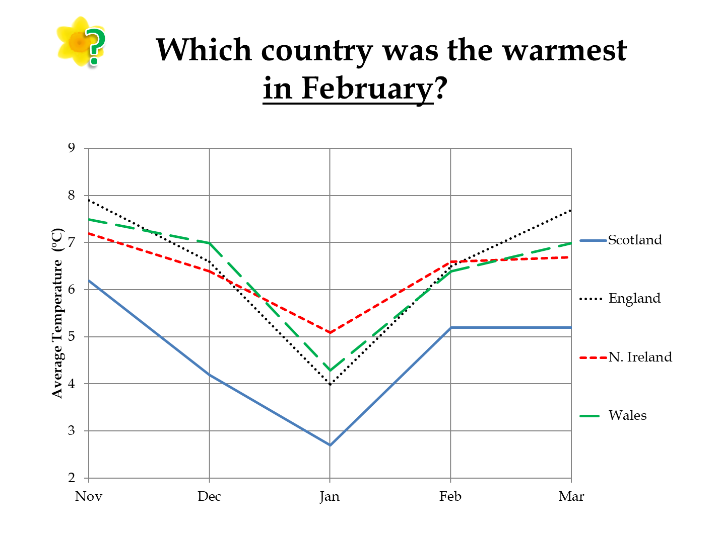

This graph shows the temperature each month from November 2018 – March 2019. We can see there was a big drop in January in all four countries, followed by a jump in temperature in February. Below are the average temperatures each month in the four countries and across the UK:
 | Nov | Dec | Jan | Feb | Mar
Scotland | 6.2°C | 4.2°C | 2.7°C | 5.2°C | 5.2°C
England | 7.9°C | 6.6°C | 4°C | 6.5°C | 7.7°C
N. Ireland | 7.2°C | 6.4°C | 5.1°C | 6.6°C | 6.7°C
Wales | 7.5°C | 7°C | 4.3°C | 6.4°C | 7.0°C

Looking at February in particular, Northern Ireland was just about the warmest but it was very close between Northern Ireland, England, and Wales. Scotland was the coldest country every month by about 1 - 2°C.

Next, we look back at our hypotheses about where daffodils will flower first, where they will be tallest, and why:
- Schools that record higher temperatures during the Bulb Project will have the earliest flowering daffodils. The effect of temperature will be more pronounced with the daffodils in pots compared to those in the ground.
- Schools that record more daily rainfall during the Bulb Project will have the earliest flowering daffodils.
- On average, daffodils in pots will flower before those planted in the ground.
- Schools in areas with higher temperatures will record taller daffodil flowering heights.
- Schools in the area with the highest level of rainfall will record taller daffodil flowering heights.

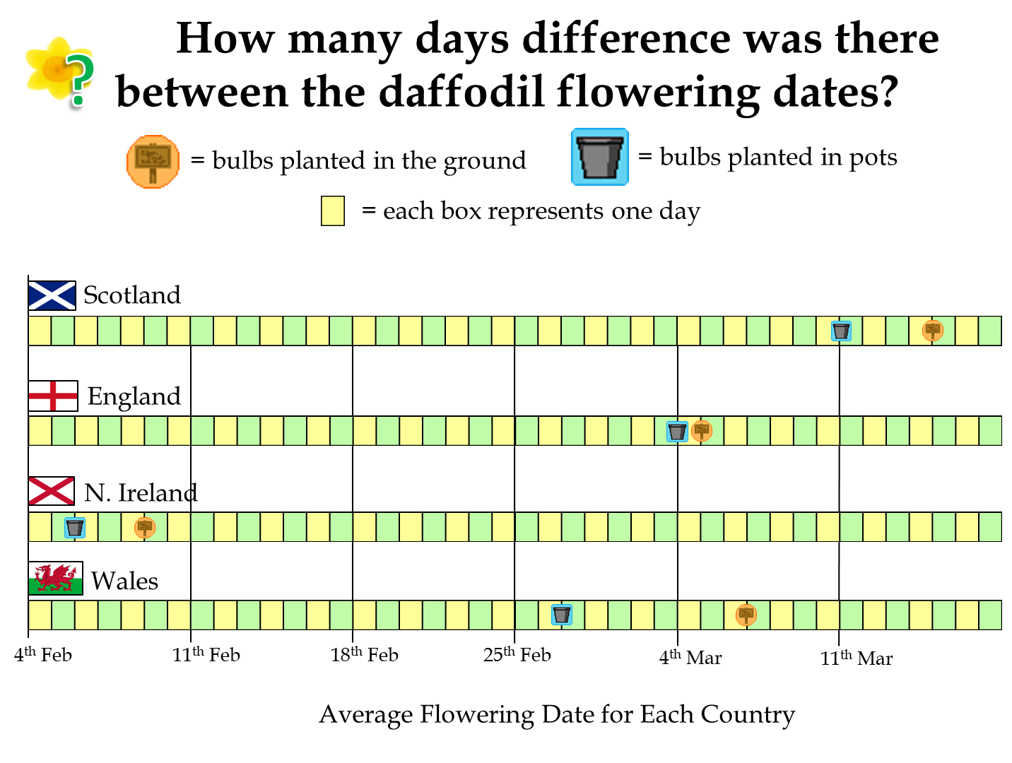
 | Pots | Ground
Scotland | 11th March | 15th March
England | 4th March | 5th March
N. Ireland | 9th Feb | 12th Feb
Wales | 27th Feb | 7th March
Daffodils flowered first in Northern Ireland, followed by Wales, England, and Scotland was the latest this year. The average flowering dates are listed in the table to the right.

Although bulbs planted in the ground flowered earlier in all four areas, a statistical test revealed that there was not a significant difference in the data sets for the bulbs in pots and bulbs in the ground.

We expected that the bulbs in pots would be less insulated from changes in temperature and therefore bulbs in pots in the warmest area would flower much earlier than those in the ground, and in the coldest area there would be less of a difference. However the data does not support our hypothesis. It does not necessarily mean our hypothesis is wrong, just that other factors had enough impact to override the temperature difference. We will come back to these other factors later.

A statistical test did show there is a moderate negative correlation between the temperature and the number of days until the daffodils in pots flowered. However, only 12 schools returned both their flowering date for bulbs in pots and their temperature records. So, as you can see from the chart to the right, this result was quite strongly influenced by two outlier schools.
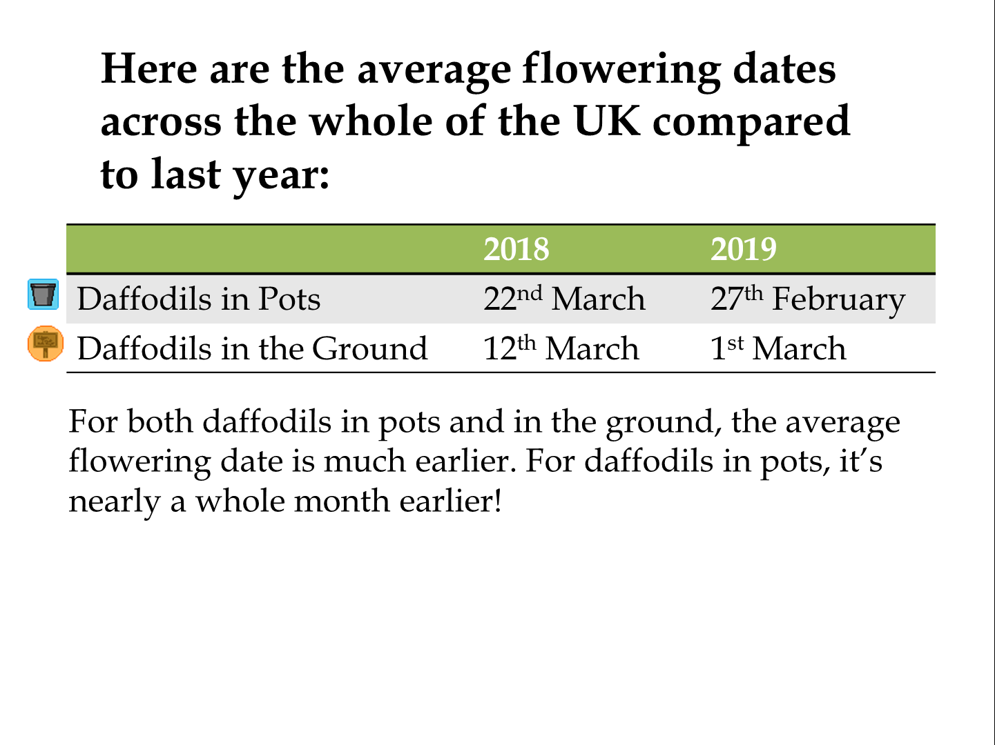

The slide shows the difference in flowering dates between bulbs in pots and in the ground, and between Spring 2018 and Spring 2019. This is the average flowering date across the whole UK.

There was a big difference in the weather between February 2018 and 2019 – just looking at some UK headlines demonstrates this. Looking at the Met Office weather information, we find that the average UK temperature in February 2018 was 2.4°C whereas in 2019 the average February temperature was 6.0°C.

Investigating our results sent in from schools, a statistical test revealed there is a significant different between the flowering dates between 2018 and 2019. There could be other reasons for this but the big difference in the spring weather is likely to be one of the main reasons.

To the left is a graph showing the temperatures sent in by schools during the last three years of the Bulb Project. You can see that 2018-19 is higher overall compared to 2017-18. However, 2016-17 was the warmest, but daffodils didn’t flower as early. This might be influenced by Northern Ireland as 2017-18 was the first year we had Bulb Buddies in Northern Ireland taking part, and that is where the earliest flowering daffodils were this year.
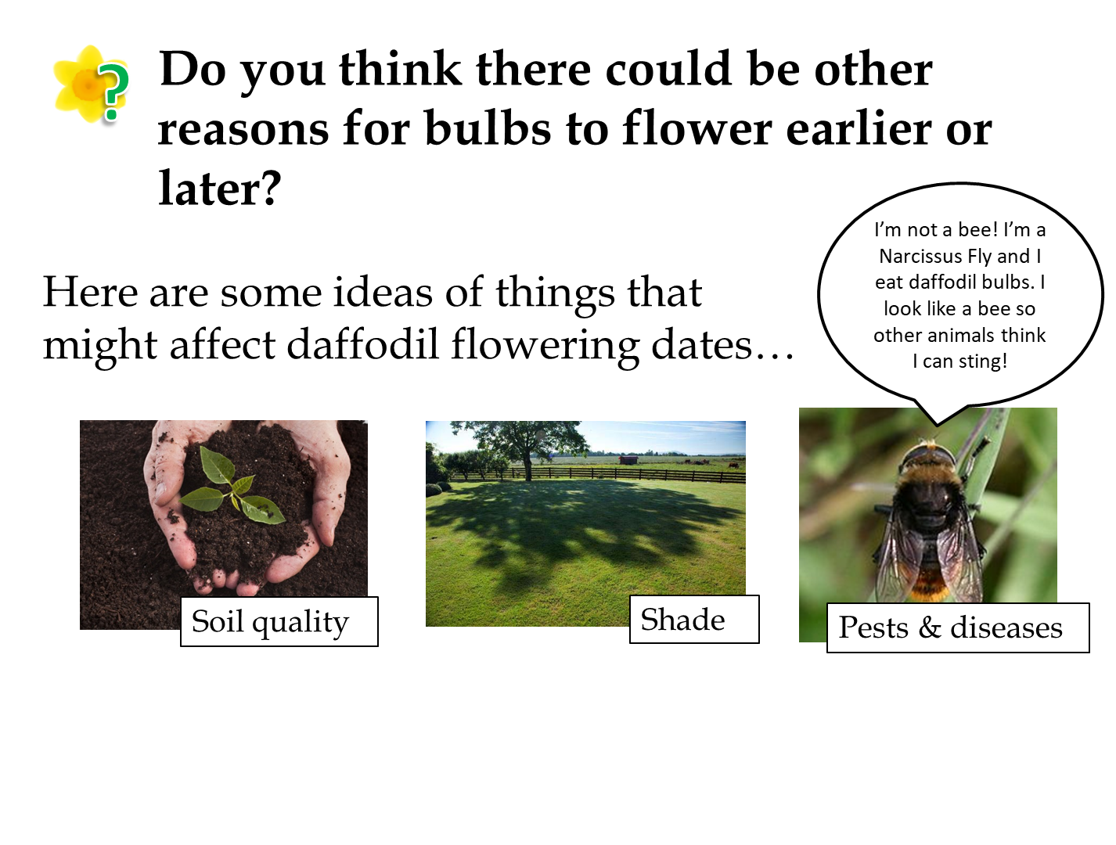

The slide shows some of our ideas for other factors that might be affecting the growth of the daffodils. They might explain why the results don’t always match our expectations.

- Soil Quality
We are not sure how much of an effect the type of soil or compost has on the growth of daffodils. Compost will hold moisture more effectively than soil, and different types of compost will hold moisture more effectively – we recommend peat-free compost due to environmental concerns. Using compost over soil should also reduce weed growth since it should not contain any stray seeds. Good drainage is important as waterlogged soil can cause the bulbs to rot, and the pH and amount of nutrients, e.g. nitrogen and potassium, in the soil will also affect growth. We would have to find a way for all schools to use the same compost to eliminate this from our investigation.

- Shade
Plants need sunlight in order to grow. Bulbs that are grown in shaded areas might grow taller in search of light, or they may not get enough sunlight to warm up and might flower later. We ask schools to keep their pots near the bulbs planted in the ground, if possible, to reduce the impact of this. There is not much else we can do as the amount of shade and hours of sunlight will differ between all schools.

- Pests and Diseases
We don’t have much control over this. We advise schools to keep their bulbs in a cool, dry place before planting day. Let us know if you notice your flowers are affected by pests!

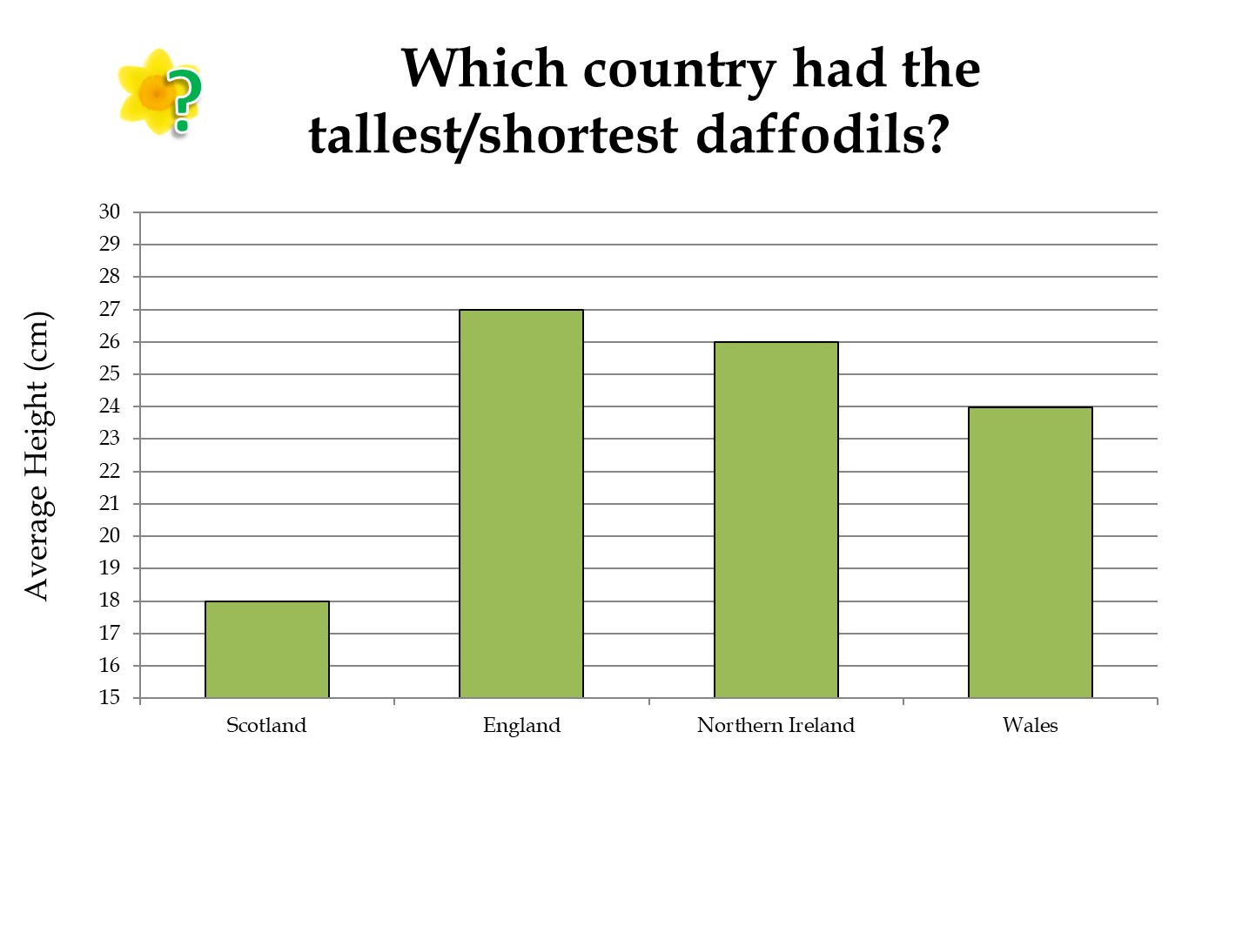

As clearly shown in the chart above, Scotland had the shortest daffodils this year. Scotland was the coldest area. England had the tallest daffodils and was the warmest area. This is in line with our prediction that the warmest area would have the tallest flowering daffodils.

Looking at the correlation, there was a slight positive correlation between temperature and height where daffodils at warmer schools grew taller. (See chart above left).

On the other hand, schools with more rain reported shorter daffodils, although this was a very weak correlation. (See chart above right).

It is important to remember that correlation does not imply causation. However the data this year gives evidence to the idea that daffodils are affected by temperature and rainfall. This leads us to consider the impact that climate change would have on daffodils and, in turn, other types of plants that live depending on the seasons.

Follow Up Activities

- Bulb Project Board Game
If you go to our website linked below, you will find a board game that can be downloaded and printed. This game can be played in small groups and is designed to encourage discussion about the various factors that could have affected the growth of your daffodils and crocuses.

Please go to this web page to download the board game and instructions:
https://www.edinatrust.org.uk/bp-results

- OPAL Air Survey
One of the factors that we have not looked at in the Bulb Project is the air quality. You may have read news reports that reveal quite shocking impacts that local air pollution can have on people and wildlife, for example: https://www.theguardian.com/environment/2018/nov/05/air-pollution-everything-you-should-know-about-a-public-health-emergency

If you are interested in the air quality around your school, there is a simple survey you can take part in that will also help provide important data to scientists. This is done by looking at lichens and fungi that are growing around your school and OPAL provides guidance to help you identify the different species.

Please go to this web page to find out how to take part in the OPAL Air Survey: https://www.opalexplorenature.org/airsurvey

Please note that the Edina Trust is not affiliated with OPAL or this Air Survey in any way, so if you have questions you will need to contact OPAL.

https://thedaffodilsociety.com/wordpress/a-guide-to-dafodils/pests-diseases/
https://www.metoffice.gov.uk/climate/uk/summaries/2018/february
https://www.metoffice.gov.uk/climate/uk/summaries/2019/february/february-2019

